Project Design Phase

Problem – Solution Fit Template

Date | 20 February 2026
Team ID | LTVIP2026TMIDS89328
Project Name | Online payments fraud detection using machine learning
Maximum Marks | 2 Marks

Problem – Solution Fit Template:
The Problem
With the rapid growth of digital transactions, online payment fraud has increased significantly.
Fraudsters perform unauthorized transactions, identity theft, and financial scams, causing major financial losses to customers and businesses.
Traditional rule-based fraud detection systems are not capable of detecting new and evolving fraud patterns effectively. This leads to delayed detection, high false alerts, and reduced customer trust.

Purpose:
- To develop an intelligent system that detects and prevents fraudulent online payment transactions using Machine Learning techniques.
- To reduce financial losses faced by customers, banks, and digital platforms due to unauthorized transactions.
- To improve the accuracy of fraud detection by identifying abnormal transaction patterns in real time.
- To minimize false positive alerts and ensure smooth experience for genuine users.
- To enhance trust, security, and reliability in digital payment systems.
- To create a scalable and adaptive fraud detection model that can handle evolving fraud techniques.

Template:
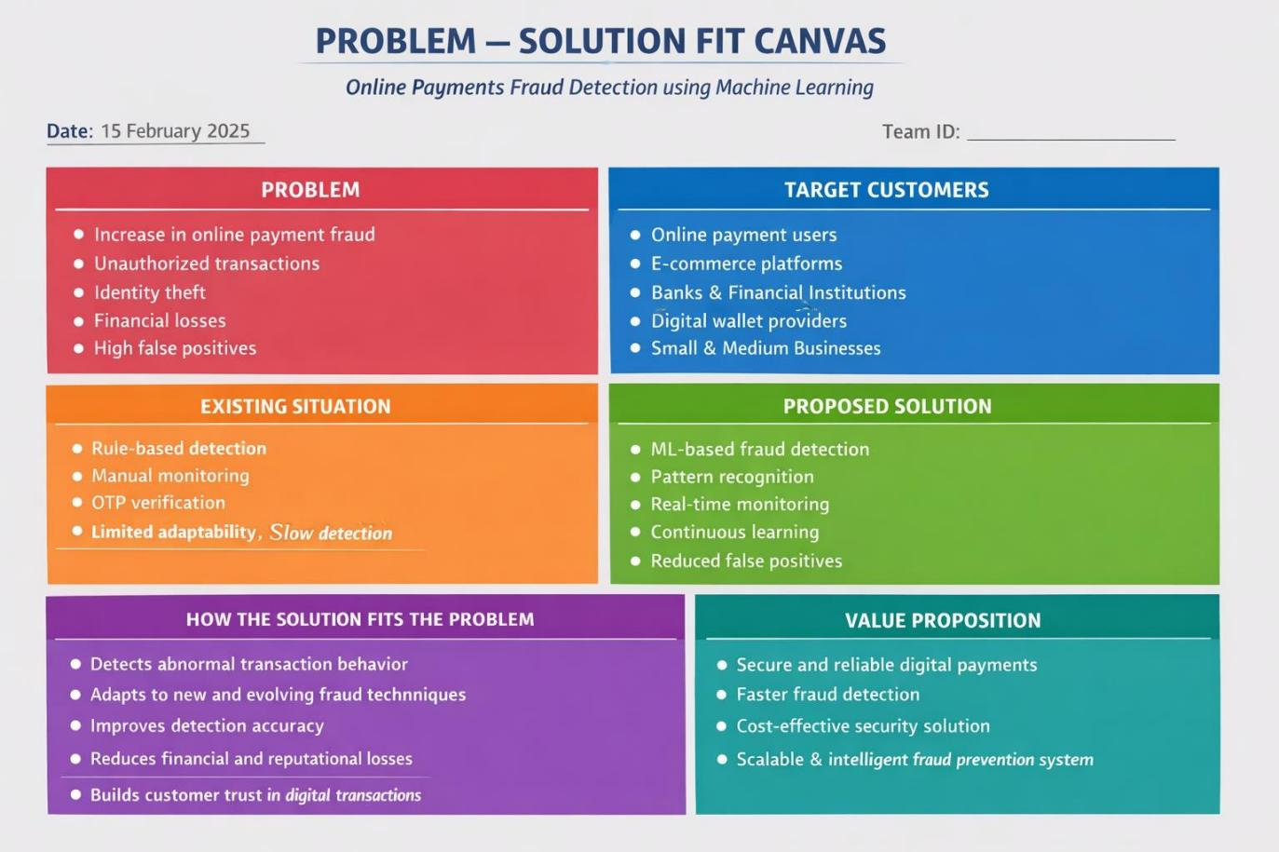

References:
- https://www.canva.com/templates/s/problem-and-solution/
- https://creately.com/diagram/example/iaMaFri43Ho/problem-solution-mapping-psm- template

